Video Forgery Detection using DNN

Abstract:

Abstract
The proliferation of digital video content has amplified the need for robust methods to detect video forgeries, especially with the advent of advanced editing tools and Deepfake technology. Video forgery, which involves tampering with the content or metadata of a video to mislead viewers, poses serious threats to authenticity, trust, and security in various domains, including journalism, law enforcement, and social media. While traditional detection techniques rely on manual inspection or heuristic-based algorithms, these methods often fall short in identifying sophisticated forgery methods.

This paper explores the application of Deep Neural Networks (DNNs) for detecting video forgeries, leveraging their capability to learn intricate patterns and anomalies in video data. By processing spatiotemporal features within video frames, DNNs can discern subtle inconsistencies introduced during manipulation. The proposed approach employs a multi-stage architecture, combining convolutional layers to extract spatial features and recurrent layers to capture temporal dependencies. The model is trained on a diverse dataset containing authentic and manipulated videos to ensure robust performance across various forgery techniques, such as frame interpolation, content splicing, and Deepfake generation.

Experimental results demonstrate the efficacy of DNN-based methods in achieving high accuracy and precision in detecting video tampering, outperforming traditional approaches. Furthermore, the system exhibits resilience against adversarial attacks and generalizes well to unseen forgery methods. This study highlights the potential of DNNs to serve as a cornerstone in the development of automated and scalable video forgery detection systems, paving the way for safeguarding digital integrity in the era of synthetic media.

INTRODUCTION:
The rapid advancements in video editing tools and deep learning technologies have revolutionized the creation and manipulation of video content. However, these advancements have also facilitated the rise of video forgery, where video footage is deliberately altered or fabricated for malicious purposes. Such manipulations pose significant risks to the credibility of digital media, including false news propagation, identity theft, and legal disputes. Consequently, the detection of video forgery has emerged as a critical area of research, necessitating robust solutions to ensure the authenticity and integrity of video content.

Deep Neural Networks (DNNs) have proven to be highly effective in a wide range of applications, including image and video processing, due to their ability to learn complex patterns and representations. Leveraging the power of DNNs, researchers have developed advanced techniques for video forgery detection. These methods aim to identify discrepancies and inconsistencies in spatial, temporal, and semantic features that may indicate tampering. By analyzing subtle artifacts introduced during editing, such as frame transitions, color mismatches, or unnatural motion patterns, DNN-based systems offer a promising approach to combating video forgery.

This field of study has gained considerable importance in the era of deepfakes—synthetic videos generated using deep learning techniques—which have further complicated the detection task. Unlike traditional video forgeries, deepfakes exhibit high levels of realism, making manual identification increasingly challenging. As a result, automated detection systems powered by DNNs are essential for addressing this sophisticated threat.

In this context, video forgery detection using DNNs not only involves the identification of tampered regions within a video but also focuses on understanding the types of forgeries, such as frame splicing, object addition/removal, or audio-video mismatches. The goal is to enhance detection accuracy while minimizing false positives, enabling the deployment of trustworthy systems in real-world applications. As video content continues to play a central role in communication and decision-making, the development of reliable forgery detection mechanisms is vital for preserving the integrity of digital media.
EXISTING SYSTEM:
Deep Learning-Based Spatio-Temporal Analysis Systems
These systems utilize convolutional neural networks (CNNs) and recurrent neural networks (RNNs) to capture spatial and temporal inconsistencies in video frames. By analyzing changes in pixel values over time, they detect tampered regions and unnatural transitions. Techniques like 3D CNNs allow joint analysis of spatial and temporal dimensions, making these systems effective in identifying frame manipulations or inter-frame forgeries.

Optical Flow Anomaly Detection Systems
Optical flow-based systems focus on motion consistency across frames. By leveraging DNNs, these systems identify disruptions in motion patterns, which often occur in cases of frame deletion, addition, or replacement. Optical flow models are particularly effective for detecting forgeries in scenarios involving moving objects or subtle edits in dynamic scenes.

Face Forgery Detection Using Pretrained Models
These systems, tailored for deepfake detection, rely on pretrained DNNs like ResNet, EfficientNet, or Vision Transformers. They analyze facial features and expressions to detect artifacts introduced by face-swapping or synthetic generation methods. Advanced systems integrate attention mechanisms to focus on regions most likely affected by forgery, such as the mouth or eyes.

Audio-Visual Synchronization Verification Systems
This category of systems employs multimodal DNNs to assess the synchronization between audio and visual components of a video. Forged videos often exhibit mismatches in lip movements and audio timing, which these systems can detect. By combining audio signal processing with visual feature extraction, these systems provide robust detection of forgeries in interviews or speeches.

Comprehensive Forgery Detection Frameworks Using GANs
Generative adversarial networks (GANs) are utilized not only to create deepfakes but also to detect them. GAN-based detection systems are trained to distinguish between real and synthetic content by learning subtle patterns introduced during forgery. These frameworks can be enhanced with adversarial training to adapt to new forgery techniques and improve detection accuracy over time.

DRAWBACKS:
1. Manual Detection Methods
Existing methods often rely on manual or semi-automated techniques for video forgery detection. These approaches require human intervention and expertise, making them time-consuming, subjective, and prone to errors. Manual methods are also inefficient when dealing with large-scale datasets.

2. Conventional Feature-Based Algorithms
Traditional video forgery detection systems utilize handcrafted features, such as motion inconsistencies or artifact analysis. However, these methods lack robustness when faced with sophisticated forgeries, such as Deepfakes, which manipulate videos in highly intricate ways.

3. Limited Scope of Detection
Most existing systems are tailored to detect specific types of forgeries, such as copy-move or splicing. This limited scope reduces their applicability in scenarios involving hybrid or novel types of video manipulation techniques.

4. Inability to Generalize Across Diverse Datasets
Many existing models perform well on specific datasets but fail to generalize effectively across diverse datasets. This lack of adaptability hampers their practical application in real-world scenarios where videos come from varied sources and formats.

5. Insufficient Computational Efficiency
The computational efficiency of many traditional systems is suboptimal, especially when processing high-resolution videos or large volumes of data. This limitation makes these systems unsuitable for real-time detection, which is crucial for many applications, such as social media content moderation.

PROPOSED SYSTEM:

1. Spatio-Temporal Forgery Detection Network
This system combines spatial and temporal features to detect forgeries in videos. It uses a two-stream DNN, where one stream processes spatial features from individual frames and the other processes temporal inconsistencies across consecutive frames. By fusing the outputs of both streams, the network effectively identifies tampered regions and temporal artifacts introduced during forgery. This approach is particularly robust against frame-level and sequence-level manipulations, such as deepfake or frame duplication.

2. Attention-Based Anomaly Detection Model
An attention mechanism is integrated into this DNN system to focus on regions of interest within video frames. The model dynamically assigns weights to different regions, prioritizing areas with suspicious patterns. By training the network on both genuine and manipulated videos, the attention mechanism learns to highlight discrepancies in texture, color, or motion. This targeted approach ensures high accuracy in identifying subtle forgeries, such as content replacement or synthetic edits.

3. Multi-Resolution Feature Extraction System
This system employs a multi-resolution DNN architecture to analyze video frames at different scales. By extracting features from low, medium, and high resolutions, the model captures inconsistencies that might be overlooked at a single resolution. This technique is particularly effective for detecting forgeries like blending artifacts, boundary mismatches, and compression anomalies. The hierarchical processing ensures that both macro and micro-level irregularities are addressed.

4. GAN-Forgery Detection Framework
A deep learning system specifically designed to combat forgeries generated by Generative Adversarial Networks (GANs). The framework employs a discriminator trained to identify the unique artifacts left by GAN-generated content, such as unnatural lighting or texture inconsistencies. By leveraging adversarial training, the model continuously adapts to new types of forgeries, ensuring its effectiveness against evolving forgery techniques.

5. Temporal Consistency Verification System
This system focuses on detecting inconsistencies in temporal dynamics, such as motion and frame sequencing. It uses recurrent neural networks (RNNs) or transformers in conjunction with convolutional layers to analyze the temporal continuity of a video. By modeling the expected temporal patterns of genuine videos, the system identifies anomalies caused by frame insertion, deletion, or reordering. This approach is particularly suited for detecting video splicing and time-based alterations.

ADVANTAGES:
1. Enhanced Accuracy in Forgery Detection
The proposed system leverages Deep Neural Networks (DNN) to achieve high precision in detecting forgeries in videos. Advanced feature extraction and learning mechanisms ensure reliable identification of subtle manipulations, such as frame tampering, deepfake content, and splicing.

2. Automation and Efficiency
With the integration of DNN, the detection process is automated, significantly reducing the time required for analysis. The system's ability to handle large datasets and perform real-time detection makes it highly efficient for practical applications.

3. Robustness Against Diverse Attacks
The system is designed to counter a wide variety of video forgery techniques, including compression artifacts, frame duplication, and synthetic content generation. Its robustness ensures consistent performance across various formats and qualities of videos.

4. Scalability for Large Datasets
The architecture of the DNN allows the proposed system to scale effectively for extensive video datasets. This scalability ensures its applicability in domains like media verification, digital forensics, and social media content moderation.

5. Adaptability to Evolving Forgery Techniques
The system employs a modular design and continuous learning mechanisms, enabling it to adapt to new forgery methods. Regular updates and training on new datasets ensure the system remains up-to-date with emerging threats in video forgery.

SYSTEM ANALYSIS:
1. Introduction
Video forgery detection is a critical field addressing the challenges of identifying tampered or manipulated videos. With the proliferation of Deepfake technology and other editing tools, ensuring video authenticity has become essential in various domains, including law enforcement, media, and cybersecurity. This system leverages Deep Neural Networks (DNNs) to detect forgery with enhanced precision and efficiency.

2. Problem Definition
The increase in video forgeries poses significant threats, including misinformation, fraud, and identity theft. Conventional methods of forgery detection rely heavily on manual inspection or feature-based algorithms, which are often insufficient against advanced manipulation techniques. There is a need for automated and robust detection systems that can efficiently handle diverse video tampering scenarios.

3. Objective
The primary objective of the proposed system is to develop a DNN-based framework capable of identifying video forgery, including frame alterations, splicing, and Deepfake manipulations. The system aims to achieve high accuracy while maintaining scalability and adaptability to new forgery techniques.

4. System Components
Data Preprocessing
Videos are preprocessed to extract frames and detect regions of interest. The preprocessing step includes noise reduction, resolution adjustment, and color correction for consistent analysis.

Feature Extraction
Leveraging DNN architectures, the system extracts spatial and temporal features from video frames. These features include pixel inconsistencies, motion dynamics, and deep-learned patterns indicative of manipulation.
Forgery Detection
A classification model is trained using labeled datasets to distinguish between forged and authentic videos. Advanced DNN architectures such as CNN-LSTM or 3D Convolutional Networks are employed to capture spatial-temporal correlations.
Post-processing
After detection, the system marks tampered regions in videos and generates detailed reports, including confidence scores and localization of manipulations.

5. Challenges
Dataset Quality and Diversity
Availability of high-quality and diverse datasets with labeled examples of forged and genuine videos is a significant challenge.
Real-Time Performance
Processing large video files in real-time demands computational efficiency without compromising accuracy.
Evolving Forgery Techniques
As forgery methods evolve, the system needs to adapt and retrain to remain effective.

6. Benefits
Automation
Reduces manual intervention by automating the detection process.
High Accuracy
Utilizes advanced DNN models to achieve superior detection rates compared to traditional methods.
Scalability
Can be extended to various video formats and platforms with minimal modifications.

7. Use Cases
Law Enforcement
Authenticating video evidence to ensure its admissibility in court.
Media Verification
Detecting manipulated videos in news reporting and social media.
Cybersecurity
Preventing identity theft and misinformation campaigns through forgery detection.

8. Conclusion
The proposed system for video forgery detection using DNN addresses critical challenges in ensuring video authenticity. By integrating cutting-edge deep learning techniques, the system offers a robust, scalable, and accurate solution to combat video manipulation.

SYSTEM REQUIREMENTS:
HARDWARE REQUIREMENTS:

• System : Pentium IV 2.4 GHz.
• Hard Disk : 40 GB.
• Ram : 512 Mb.

SOFTWARE REQUIREMENTS:

• Operating system : - Windows.
• Coding Language : python.

System Architecture:

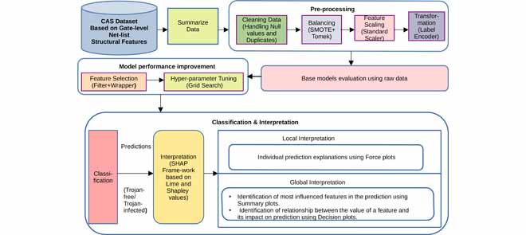

UML Diagrams:

CLASS DIAGRAM:
The class diagram is used to refine the use case diagram and define a detailed design of the system. The class diagram classifies the actors defined in the use case diagram into a set of interrelated classes. The relationship or association between the classes can be either an "is-a" or "has-a" relationship. Each class in the class diagram may be capable of providing certain functionalities. These functionalities provided by the class are termed "methods" of the class. Apart from this, each class may have certain "attributes" that uniquely.

Use case Diagram:
A use case diagram in the Unified Modelling Language (UML) is a type of behavioural diagram defined by and created from a Use-case analysis. Its purpose is to present a graphical overview of the functionality provided by a system in terms of actors, their goals (represented as use cases), and any dependencies between those use cases. The main purpose of a use case diagram is to show what system functions are performed for which actor. Roles of the actors in the system can be depicted.

Sequence Diagram:
A sequence diagram represents the interaction between different objects in the system. The important aspect of a sequence diagram is that it is time-ordered. This means that the exact sequence of the interactions between the objects is represented step by step. Different objects in the sequence diagram interact with each other by passing "messages".

Collaborative Diagram:
A collaboration diagram groups together the interactions between different objects. The interactions are listed as numbered interactions that help to trace the sequence of the interactions. The collaboration diagram helps to identify all the possible interactions that each object has with other objects.

System Implementations:

- Data Pre processing: Prepare the textual data by removing noise, such as special characters, punctuation, and stop words. Tokenize the text into sentences or paragraphs to facilitate sentiment analysis and summarization.
- Sentiment Analysis Model: Implement or utilize pre-trained sentiment analysis models capable of accurately detecting the sentiment polarity (positive, negative, neutral) of each sentence or paragraph in the text. Consider employing advanced techniques such as deep learning-based models or transformer architectures for improved accuracy.
- Summarization Model: Implement a text summarization model capable of generating concise summaries while incorporating sentiment information. Explore both extractive and abstractive summarization techniques, considering factors such as coherence, informativeness, and sentiment preservation.
- Integration: Integrate the sentiment analysis module with the summarization module to leverage sentiment information during the summarization process. Design mechanisms to prioritize or adjust the inclusion of sentences based on their sentiment polarity to ensure that the generated summaries reflect the emotional context of the original text.
- Evaluation: Evaluate the performance of the implemented system using standard metrics such as ROUGE (Recall-Oriented Understudy for Gisting Evaluation) for summarization quality and sentiment classification accuracy metrics for sentiment analysis. Conduct thorough evaluations using benchmark datasets to assess the effectiveness and robustness of the system.
- Optimization: Optimize the system for efficiency and scalability by leveraging techniques such as parallel processing, caching, and model compression. Consider deploying the system on distributed computing frameworks or utilizing hardware accelerators (e.g., GPUs) to improve processing speed and resource utilization.
- User Interface: Develop a user-friendly interface for interacting with the system, allowing users to input text and view the generated summaries along with sentiment analysis results. Design the interface to be intuitive, responsive, and accessible across different devices and platforms.
- Deployment: Deploy the implemented system in production environments, considering factors such as scalability, reliability, and security. Ensure proper monitoring and maintenance procedures are in place to address potential issues and ensure continuous performance optimization.
- Feedback Loop: Establish a feedback loop to gather user feedback and monitor system performance over time. Use feedback to iteratively improve the system's accuracy, usability, and effectiveness based on user requirements and evolving needs.

System Environment:

What is Python :-
Below are some facts about Python.
Python is currently the most widely used multi-purpose, high-level programming language.
Python allows programming in Object-Oriented and Procedural paradigms. Python programs generally are smaller than other programming languages like Java.
Programmers have to type relatively less and indentation requirement of the language, makes them readable all the time.
Python language is being used by almost all tech-giant companies like – Google, Amazon, Facebook, Instagram, Dropbox, Uber… etc.
The biggest strength of Python is huge collection of standard library which can be used for the following .
  - Machine Learning
  - GUI Applications (like Kivy, Tkinter, PyQt etc. )
  - Web frameworks like Django (used by YouTube, Instagram, Dropbox)
  - Image processing (like Opencv, Pillow)
  - Web scraping (like Scrapy, BeautifulSoup, Selenium)
  - Test frameworks
  - Multimedia

Advantages of Python :-
Let’s see how Python dominates over other languages.

1. Extensive Libraries
Python downloads with an extensive library and it contain code for various purposes like regular expressions, documentation-generation, unit-testing, web browsers, threading, databases, CGI, email, image manipulation, and more. So, we don’t have to write the complete code for that manually.

2. Extensible
As we have seen earlier, Python can be extended to other languages. You can write some of your code in languages like C++ or C. This comes in handy, especially in projects.

3. Embeddable
Complimentary to extensibility, Python is embeddable as well. You can put your Python code in your source code of a different language, like C++. This lets us add scripting capabilities to our code in the other language.

4. Improved Productivity
The language’s simplicity and extensive libraries render programmers more productive than languages like Java and C++ do. Also, the fact that you need to write less and get more things done.

5. IOT Opportunities
Since Python forms the basis of new platforms like Raspberry Pi, it finds the future bright for the Internet Of Things. This is a way to connect the language with the real world.

6. Simple and Easy
When working with Java, you may have to create a class to print ‘Hello World’. But in Python, just a print statement will do. It is also quite easy to learn, understand, and code. This is why when people pick up Python, they have a hard time adjusting to other more verbose languages like Java.

7. Readable
Because it is not such a verbose language, reading Python is much like reading English. This is the reason why it is so easy to learn, understand, and code. It also does not need curly braces to define blocks, and indentation is mandatory. This further aids the readability of the code.

8. Object-Oriented
This language supports both the procedural and object-oriented programming paradigms. While functions help us with code reusability, classes and objects let us model the real world. A class allows the encapsulation of data and functions into one.

9. Free and Open-Source
Like we said earlier, Python is freely available. But not only can you download Python for free, but you can also download its source code, make changes to it, and even distribute it. It downloads with an extensive collection of libraries to help you with your tasks.

10. Portable
When you code your project in a language like C++, you may need to make some changes to it if you want to run it on another platform. But it isn’t the same with Python. Here, you need to code only once, and you can run it anywhere. This is called Write Once Run Anywhere (WORA). However, you need to be careful enough not to include any system-dependent features.

11. Interpreted
Lastly, we will say that it is an interpreted language. Since statements are executed one by one, debugging is easier than in compiled languages.
Any doubts till now in the advantages of Python? Mention in the comment section.

Advantages of Python Over Other Languages

1. Less Coding
Almost all of the tasks done in Python requires less coding when the same task is done in other languages. Python also has an awesome standard library support, so you don’t have to search for any third-party libraries to get your job done. This is the reason that many people suggest learning Python to beginners.

2. Affordable
Python is free therefore individuals, small companies or big organizations can leverage the free available resources to build applications. Python is popular and widely used so it gives you better community support.
The 2019 Github annual survey showed us that Python has overtaken Java in the most popular programming language category.

3. Python is for Everyone
Python code can run on any machine whether it is Linux, Mac or Windows. Programmers need to learn different languages for different jobs but with Python, you can professionally build web apps, perform data analysis and machine learning, automate things, do web scraping and also build games and powerful visualizations. It is an all-rounder programming language.

Disadvantages of Python
So far, we’ve seen why Python is a great choice for your project. But if you choose it, you should be aware of its consequences as well. Let’s now see the downsides of choosing Python over another language.

1. Speed Limitations
We have seen that Python code is executed line by line. But since Python is interpreted, it often results in slow execution. This, however, isn’t a problem unless speed is a focal point for the project. In other words, unless high speed is a requirement, the benefits offered by Python are enough to distract us from its speed limitations.

2. Weak in Mobile Computing and Browsers
While it serves as an excellent server-side language, Python is much rarely seen on the client-side. Besides that, it is rarely ever used to implement smartphone-based applications. One such application is called Carbonnelle.
The reason it is not so famous despite the existence of Brython is that it isn’t that secure.

3. Design Restrictions
As you know, Python is dynamically-typed. This means that you don’t need to declare the type of variable while writing the code. It uses duck-typing. But wait, what’s that? Well, it just means that if it looks like a duck, it must be a duck. While this is easy on the programmers during coding, it can raise run-time errors.

4. Underdeveloped Database Access Layers
Compared to more widely used technologies like JDBC (Java DataBase Connectivity) and ODBC (Open DataBase Connectivity), Python’s database access layers are a bit underdeveloped. Consequently, it is less often applied in huge enterprises.

5. Simple
No, we’re not kidding. Python’s simplicity can indeed be a problem. Take my example. I don’t do Java, I’m more of a Python person. To me, its syntax is so simple that the verbosity of Java code seems unnecessary.
This was all about the Advantages and Disadvantages of Python Programming Language.
History of Python : -

What do the alphabet and the programming language Python have in common? Right, both start with ABC. If we are talking about ABC in the Python context, it's clear that the programming language ABC is meant. ABC is a general-purpose programming language and programming environment, which had been developed in the Netherlands, Amsterdam, at the CWI (Centrum Wiskunde &Informatica). The greatest achievement of ABC was to influence the design of Python.Python was conceptualized in the late 1980s. Guido van Rossum worked that time in a project at the CWI, called Amoeba, a distributed operating system. In an interview with Bill Venners¹, Guido van Rossum said: "In the early 1980s, I worked as an implementer on a team building a language called ABC at Centrum voor Wiskunde en Informatica (CWI).
I don't know how well people know ABC's influence on Python. I try to mention ABC's influence because I'm indebted to everything I learned during that project and to the people who worked on it."Later on in the same Interview, Guido van Rossum continued: "I remembered all my experience and some of my frustration with ABC. I decided to try to design a simple scripting language that possessed some of ABC's better properties, but without its problems. So I started typing. I created a simple virtual machine, a simple parser, and a simple runtime. I made my own version of the various ABC parts that I liked. I created a basic syntax, used indentation for statement grouping instead of curly braces or begin-end blocks, and developed a small number of powerful data types: a hash table (or dictionary, as we call it), a list, strings, and numbers."

What is Machine Learning : -
Before we take a look at the details of various machine learning methods, let's start by looking at what machine learning is, and what it isn't. Machine learning is often categorized as a subfield of artificial intelligence, but I find that categorization can often be misleading at first brush. The study of machine learning certainly arose from research in this context, but in the data science application of machine learning methods, it's more helpful to think of machine learning as a means of building models of data.
Fundamentally, machine learning involves building mathematical models to help understand data. "Learning" enters the fray when we give these models tunable parameters that can be adapted to observed data; in this way the program can be considered to be "learning" from the data.
Once these models have been fit to previously seen data, they can be used to predict and understand aspects of newly observed data. I'll leave to the reader the more philosophical digression regarding the extent to which this type of mathematical, model-based "learning" is similar to the "learning" exhibited by the human brain.Understanding the problem setting in machine learning is essential to using these tools effectively, and so we will start with some broad categorizations of the types of approaches we'll discuss here.
Categories Of Machine Leaning :-
At the most fundamental level, machine learning can be categorized into two main types: supervised learning and unsupervised learning.
Supervised learning involves somehow modeling the relationship between measured features of data and some label associated with the data; once this model is determined, it can be used to apply labels to new, unknown data. This is further subdivided into classification tasks and regression tasks: in classification, the labels are discrete categories, while in regression, the labels are continuous quantities. We will see examples of both types of supervised learning in the following section.

Unsupervised learning involves modeling the features of a dataset without reference to any label, and is often described as "letting the dataset speak for itself." These models include tasks such as clustering and dimensionality reduction.
Clustering algorithms identify distinct groups of data, while dimensionality reduction algorithms search for more succinct representations of the data. We will see examples of both types of unsupervised learning in the following section.

Need for Machine Learning
Human beings, at this moment, are the most intelligent and advanced species on earth because they can think, evaluate and solve complex problems. On the other side, AI is still in its initial stage and haven’t surpassed human intelligence in many aspects. Then the question is that what is the need to make machine learn? The most suitable reason for doing this is, “to make decisions, based on data, with efficiency and scale”.
Lately, organizations are investing heavily in newer technologies like Artificial Intelligence, Machine Learning and Deep Learning to get the key information from data to perform several real-world tasks and solve problems. We can call it data-driven decisions taken by machines, particularly to automate the process. These data-driven decisions can be used, instead of using programing logic, in the problems that cannot be programmed inherently. The fact is that we can’t do without human intelligence, but other aspect is that we all need to solve real-world problems with efficiency at a huge scale. That is why the need for machine learning arises.

Challenges in Machines Learning :-

While Machine Learning is rapidly evolving, making significant strides with cybersecurity and autonomous cars, this segment of AI as whole still has a long way to go. The reason behind is that ML has not been able to overcome number of challenges. The challenges that ML is facing currently are −
Quality of data − Having good-quality data for ML algorithms is one of the biggest challenges. Use of low-quality data leads to the problems related to data preprocessing and feature extraction.
Time-Consuming task − Another challenge faced by ML models is the consumption of time especially for data acquisition, feature extraction and retrieval.
Lack of specialist persons − As ML technology is still in its infancy stage, availability of expert resources is a tough job.
No clear objective for formulating business problems − Having no clear objective and well-defined goal for business problems is another key challenge for ML because this technology is not that mature yet.
Issue of overfitting & underfitting − If the model is overfitting or underfitting, it cannot be represented well for the problem.
Curse of dimensionality − Another challenge ML model faces is too many features of data points. This can be a real hindrance.
Difficulty in deployment − Complexity of the ML model makes it quite difficult to be deployed in real life.

Applications of Machines Learning :-

Machine Learning is the most rapidly growing technology and according to researchers we are in the golden year of AI and ML. It is used to solve many real-world complex problems which cannot be solved with traditional approach. Following are some real-world applications of ML −
- Emotion analysis
- Sentiment analysis
- Error detection and prevention
- Weather forecasting and prediction
- Stock market analysis and forecasting
- Speech synthesis
- Speech recognition
- Customer segmentation
- Object recognition
- Fraud detection
- Fraud prevention
- Recommendation of products to customer in online shopping

How to Start Learning Machine Learning?
Arthur Samuel coined the term “Machine Learning” in 1959 and defined it as a “Field of study that gives computers the capability to learn without being explicitly programmed”.
And that was the beginning of Machine Learning! In modern times, Machine Learning is one of the most popular (if not the most!) career choices. According to Indeed, Machine Learning Engineer Is The Best Job of 2019 with a 344% growth and an average base salary of $146,085 per year.
But there is still a lot of doubt about what exactly is Machine Learning and how to start learning it? So this article deals with the Basics of Machine Learning and also the path you can follow to eventually become a full-fledged Machine Learning Engineer. Now let’s get started!!!

How to start learning ML?
This is a rough roadmap you can follow on your way to becoming an insanely talented Machine Learning Engineer. Of course, you can always modify the steps according to your needs to reach your desired end-goal!

Step 1 – Understand the Prerequisites
In case you are a genius, you could start ML directly but normally, there are some prerequisites that you need to know which include Linear Algebra, Multivariate Calculus, Statistics, and Python. And if you don’t know these, never fear! You don’t need a Ph.D. degree in these topics to get started but you do need a basic understanding.

(a) Learn Linear Algebra and Multivariate Calculus
Both Linear Algebra and Multivariate Calculus are important in Machine Learning. However, the extent to which you need them depends on your role as a data scientist. If you are more focused on application heavy machine learning, then you will not be that heavily focused on maths as there are many common libraries available. But if you want to focus on R&D in Machine Learning, then mastery of Linear Algebra and Multivariate Calculus is very important as you will have to implement many ML algorithms from scratch.

(b) Learn Statistics
Data plays a huge role in Machine Learning. In fact, around 80% of your time as an ML expert will be spent collecting and cleaning data. And statistics is a field that handles the collection, analysis, and presentation of data. So it is no surprise that you need to learn it!!!
Some of the key concepts in statistics that are important are Statistical Significance, Probability Distributions, Hypothesis Testing, Regression, etc. Also, Bayesian Thinking is also a very important part of ML which deals with various concepts like Conditional Probability, Priors, and Posteriors, Maximum Likelihood, etc.

(c) Learn Python
Some people prefer to skip Linear Algebra, Multivariate Calculus and Statistics and learn them as they go along with trial and error. But the one thing that you absolutely cannot skip is Python! While there are other languages you can use for Machine Learning like R, Scala, etc. Python is currently the most popular language for ML. In fact, there are many Python libraries that are specifically useful for Artificial Intelligence and Machine Learning such as Keras, TensorFlow, Scikit-learn, etc.
So if you want to learn ML, it’s best if you learn Python! You can do that using various online resources and courses such as Fork Python available Free on GeeksforGeeks.

Step 2 – Learn Various ML Concepts
Now that you are done with the prerequisites, you can move on to actually learning ML (Which is the fun part!!!) It’s best to start with the basics and then move on to the more complicated stuff. Some of the basic concepts in ML are:

(a) Terminologies of Machine Learning
- Model – A model is a specific representation learned from data by applying some machine learning algorithm. A model is also called a hypothesis.
- Feature – A feature is an individual measurable property of the data. A set of numeric features can be conveniently described by a feature vector. Feature vectors are fed as input to the model. For example, in order to predict a fruit, there may be features like color, smell, taste, etc.
- Target (Label) – A target variable or label is the value to be predicted by our model. For the fruit example discussed in the feature section, the label with each set of input would be the name of the fruit like apple, orange, banana, etc.
- Training – The idea is to give a set of inputs(features) and it’s expected outputs(labels), so after training, we will have a model (hypothesis) that will then map new data to one of the categories trained on.
- Prediction – Once our model is ready, it can be fed a set of inputs to which it will provide a predicted output(label).

(b) Types of Machine Learning
- Supervised Learning – This involves learning from a training dataset with labeled data using classification and regression models. This learning process continues until the required level of performance is achieved.
- Unsupervised Learning – This involves using unlabelled data and then finding the underlying structure in the data in order to learn more and more about the data itself using factor and cluster analysis models.
- Semi-supervised Learning – This involves using unlabelled data like Unsupervised Learning with a small amount of labeled data. Using labeled data vastly increases the learning accuracy and is also more cost-effective than Supervised Learning.
- Reinforcement Learning – This involves learning optimal actions through trial and error. So the next action is decided by learning behaviors that are based on the current state and that will maximize the reward in the future.

Advantages of Machine learning :-

1. Easily identifies trends and patterns -
Machine Learning can review large volumes of data and discover specific trends and patterns that would not be apparent to humans. For instance, for an e-commerce website like Amazon, it serves to understand the browsing behaviors and purchase histories of its users to help cater to the right products, deals, and reminders relevant to them. It uses the results to reveal relevant advertisements to them.

2. No human intervention needed (automation)
With ML, you don’t need to babysit your project every step of the way. Since it means giving machines the ability to learn, it lets them make predictions and also improve the algorithms on their own. A common example of this is anti-virus softwares; they learn to filter new threats as they are recognized. ML is also good at recognizing spam.

3. Continuous Improvement
As ML algorithms gain experience, they keep improving in accuracy and efficiency. This lets them make better decisions. Say you need to make a weather forecast model. As the amount of data you have keeps growing, your algorithms learn to make more accurate predictions faster.

4. Handling multi-dimensional and multi-variety data
Machine Learning algorithms are good at handling data that are multi-dimensional and multi-variety, and they can do this in dynamic or uncertain environments.

5. Wide Applications
You could be an e-tailer or a healthcare provider and make ML work for you. Where it does apply, it holds the capability to help deliver a much more personal experience to customers while also targeting the right customers.

Disadvantages of Machine Learning :-

1. Data Acquisition
Machine Learning requires massive data sets to train on, and these should be inclusive/unbiased, and of good quality. There can also be times where they must wait for new data to be generated.

2. Time and Resources
ML needs enough time to let the algorithms learn and develop enough to fulfill their purpose with a considerable amount of accuracy and relevancy. It also needs massive resources to function. This can mean additional requirements of computer power for you.

3. Interpretation of Results
Another major challenge is the ability to accurately interpret results generated by the algorithms. You must also carefully choose the algorithms for your purpose.

4. High error-susceptibility
Machine Learning is autonomous but highly susceptible to errors. Suppose you train an algorithm with data sets small enough to not be inclusive. You end up with biased predictions coming from a biased training set. This leads to irrelevant advertisements being displayed to customers. In the case of ML, such blunders can set off a chain of errors that can go undetected for long periods of time. And when they do get noticed, it takes quite some time to recognize the source of the issue, and even longer to correct it.

Python Development Steps : -
Guido Van Rossum published the first version of Python code (version 0.9.0) at alt.sources in February 1991. This release included already exception handling, functions, and the core data types of list, dict, str and others. It was also object oriented and had a module system.
Python version 1.0 was released in January 1994. The major new features included in this release were the functional programming tools lambda, map, filter and reduce, which Guido Van Rossum never liked.Six and a half years later in October 2000, Python 2.0 was introduced. This release included list comprehensions, a full garbage collector and it was supporting unicode.Python flourished for another 8 years in the versions 2.x before the next major release as Python 3.0 (also known as "Python 3000" and "Py3K") was released. Python 3 is not backwards compatible with Python 2.x.

The emphasis in Python 3 had been on the removal of duplicate programming constructs and modules, thus fulfilling or coming close to fulfilling the 13th law of the Zen of Python: "There should be one -- and preferably only one -- obvious way to do it."Some changes in Python 7.3:
- Print is now a function
- Views and iterators instead of lists
- The rules for ordering comparisons have been simplified. E.g. a heterogeneous list cannot be sorted, because all the elements of a list must be comparable to each other.
- There is only one integer type left, i.e. int. long is int as well.
- The division of two integers returns a float instead of an integer. "//" can be used to have the "old" behaviour.
- Text Vs. Data Instead Of Unicode Vs. 8-bit
Purpose :-
We demonstrated that our approach enables successful segmentation of intra-retinal layers—even with low-quality images containing speckle noise, low contrast, and different intensity ranges throughout—with the assistance of the ANIS feature.

Python
Python is an interpreted high-level programming language for general-purpose programming. Created by Guido van Rossum and first released in 1991, Python has a design philosophy that emphasizes code readability, notably using significant whitespace.
Python features a dynamic type system and automatic memory management. It supports multiple programming paradigms, including object-oriented, imperative, functional and procedural, and has a large and comprehensive standard library.
- Python is Interpreted − Python is processed at runtime by the interpreter. You do not need to compile your program before executing it. This is similar to PERL and PHP.
- Python is Interactive − you can actually sit at a Python prompt and interact with the interpreter directly to write your programs.
Python also acknowledges that speed of development is important. Readable and terse code is part of this, and so is access to powerful constructs that avoid tedious repetition of code. Maintainability also ties into this may be an all but useless metric, but it does say something about how much code you have to scan, read and/or understand to troubleshoot problems or tweak behaviors. This speed of development, the ease with which a programmer of other languages can pick up basic Python skills and the huge standard library is key to another area where Python excels. All its tools have been quick to implement, saved a lot of time, and several of them have later been patched and updated by people with no Python background - without breaking.

Modules Used in Project :-
Tensorflow
TensorFlow is a free and open-source software library for dataflow and differentiable programming across a range of tasks. It is a symbolic math library, and is also used for machine learning applications such as neural networks. It is used for both research and production at Google.‍
TensorFlow was developed by the Google Brain team for internal Google use. It was released under the Apache 2.0 open-source license on November 9, 2015.
Numpy
Numpy is a general-purpose array-processing package. It provides a high-performance multidimensional array object, and tools for working with these arrays.
It is the fundamental package for scientific computing with Python. It contains various features including these important ones:
- A powerful N-dimensional array object
- Sophisticated (broadcasting) functions
- Tools for integrating C/C++ and Fortran code
- Useful linear algebra, Fourier transform, and random number capabilities
Besides its obvious scientific uses, Numpy can also be used as an efficient multi-dimensional container of generic data. Arbitrary data-types can be defined using Numpy which allows Numpy to seamlessly and speedily integrate with a wide variety of databases.

Pandas
Pandas is an open-source Python Library providing high-performance data manipulation and analysis tool using its powerful data structures. Python was majorly used for data munging and preparation. It had very little contribution towards data analysis. Pandas solved this problem. Using Pandas, we can accomplish five typical steps in the processing and analysis of data, regardless of the origin of data load, prepare, manipulate, model, and analyze. Python with Pandas is used in a wide range of fields including academic and commercial domains including finance, economics, Statistics, analytics, etc.
Matplotlib
Matplotlib is a Python 2D plotting library which produces publication quality figures in a variety of hardcopy formats and interactive environments across platforms. Matplotlib can be used in Python scripts, the Python and IPython shells, the Jupyter Notebook, web application servers, and four graphical user interface toolkits. Matplotlib tries to make easy things easy and hard things possible. You can generate plots, histograms, power spectra, bar charts, error charts, scatter plots, etc., with just a few lines of code. For examples, see the sample plots and thumbnail gallery.
For simple plotting the pyplot module provides a MATLAB-like interface, particularly when combined with IPython. For the power user, you have full control of line styles, font properties, axes properties, etc, via an object oriented interface or via a set of functions familiar to MATLAB users.

Scikit – learn
Scikit-learn provides a range of supervised and unsupervised learning algorithms via a consistent interface in Python. It is licensed under a permissive simplified BSD license and is distributed under many Linux distributions, encouraging academic and commercial use. Python
Python is an interpreted high-level programming language for general-purpose programming. Created by Guido van Rossum and first released in 1991, Python has a design philosophy that emphasizes code readability, notably using significant whitespace.
Python features a dynamic type system and automatic memory management. It supports multiple programming paradigms, including object-oriented, imperative, functional and procedural, and has a large and comprehensive standard library.
- Python is Interpreted − Python is processed at runtime by the interpreter. You do not need to compile your program before executing it. This is similar to PERL and PHP.
- Python is Interactive − you can actually sit at a Python prompt and interact with the interpreter directly to write your programs.
Python also acknowledges that speed of development is important. Readable and terse code is part of this, and so is access to powerful constructs that avoid tedious repetition of code. Maintainability also ties into this may be an all but useless metric, but it does say something about how much code you have to scan, read and/or understand to troubleshoot problems or tweak behaviors. This speed of development, the ease with which a programmer of other languages can pick up basic Python skills and the huge standard library is key to another area where Python excels.
All its tools have been quick to implement, saved a lot of time, and several of them have later been patched and updated by people with no Python background - without breaking.
Install Python Step-by-Step in Windows and Mac :
Python a versatile programming language doesn’t come pre-installed on your computer devices. Python was first released in the year 1991 and until today it is a very popular high-level programming language. Its style philosophy emphasizes code readability with its notable use of great whitespace.
The object-oriented approach and language construct provided by Python enables programmers to write both clear and logical code for projects. This software does not come pre-packaged with Windows.

How to Install Python on Windows and Mac :

There have been several updates in the Python version over the years. The question is how to install Python? It might be confusing for the beginner who is willing to start learning Python but this tutorial will solve your query. The latest or the newest version of Python is version 3.7.4 or in other words, it is Python 3.
Note: The python version 3.7.4 cannot be used on Windows XP or earlier devices.

Before you start with the installation process of Python. First, you need to know about your System Requirements. Based on your system type i.e. operating system and based processor, you must download the python version. My system type is a Windows 64-bit operating system. So the steps below are to install python version 3.7.4 on Windows 7 device or to install Python 3. Download the Python Cheatsheet here.The steps on how to install Python on Windows 10, 8 and 7 are divided into 4 parts to help understand better.

Download the Correct version into the system

Step 1: Go to the official site to download and install python using Google Chrome or any other web browser. OR Click on the following link: https://www.python.org

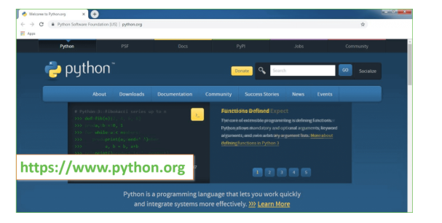
Now, check for the latest and the correct version for your operating system.
Step 2: Click on the Download Tab.
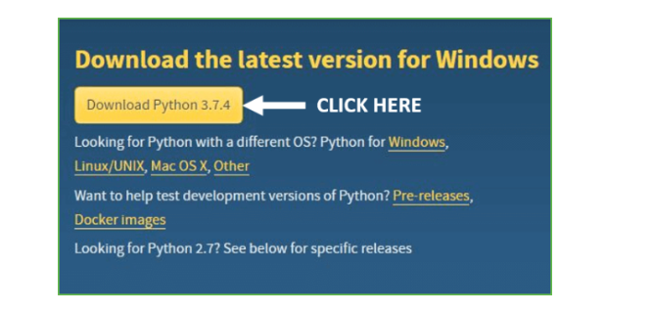
Step 3: You can either select the Download Python for windows 3.7.4 button in Yellow Color or you can scroll further down and click on download with respective to their version. Here, we are downloading the most recent python version for windows 3.7.4
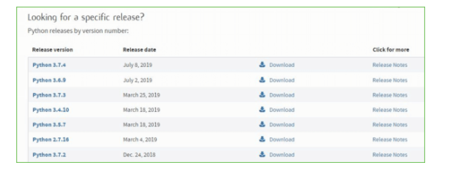
Step 4: Scroll down the page until you find the Files option.

Step 5: Here you see a different version of python along with the operating system.

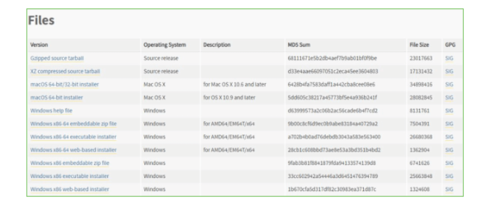

• To download Windows 32-bit python, you can select any one from the three options: Windows x86 embeddable zip file, Windows x86 executable installer or Windows x86 web-based installer.
•To download Windows 64-bit python, you can select any one from the three options: Windows x86-64 embeddable zip file, Windows x86-64 executable installer or Windows x86-64 web-based installer.
Here we will install Windows x86-64 web-based installer. Here your first part regarding which version of python is to be downloaded is completed. Now we move ahead with the second part in installing python i.e. Installation
Note: To know the changes or updates that are made in the version you can click on the Release Note Option.

Installation of Python
Step 1: Go to Download and Open the downloaded python version to carry out the installation process.
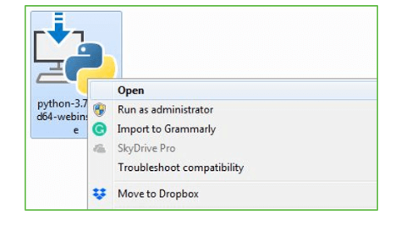
Step 2: Before you click on Install Now, Make sure to put a tick on Add Python 3.7 to PATH.

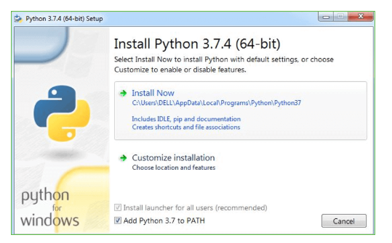

Step 3: Click on Install NOW After the installation is successful. Click on Close.



With these above three steps on python installation, you have successfully and correctly installed Python. Now is the time to verify the installation.
Note: The installation process might take a couple of minutes.

Verify the Python Installation
Step 1: Click on Start
Step 2: In the Windows Run Command, type “cmd”.

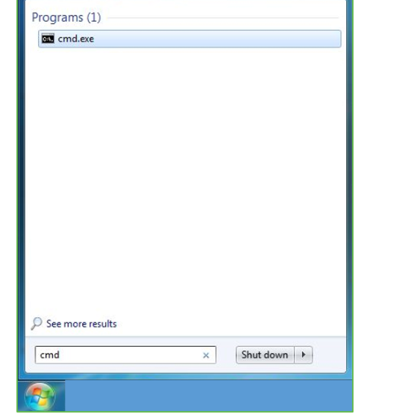
Step 3: Open the Command prompt option.
Step 4: Let us test whether the python is correctly installed. Type python –V and press Enter.

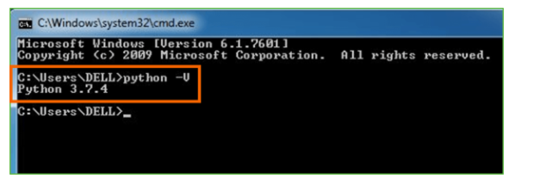
Step 5: You will get the answer as 3.7.4
Note: If you have any of the earlier versions of Python already installed. You must first uninstall the earlier version and then install the new one.

Check how the Python IDLE works
Step 1: Click on Start
Step 2: In the Windows Run command, type “python idle”.
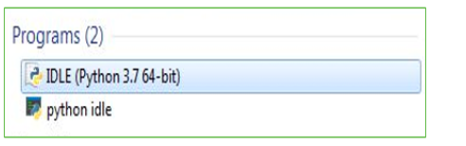
Step 3: Click on IDLE (Python 3.7 64-bit) and launch the program
Step 4: To go ahead with working in IDLE you must first save the file. Click on File > Click on Save

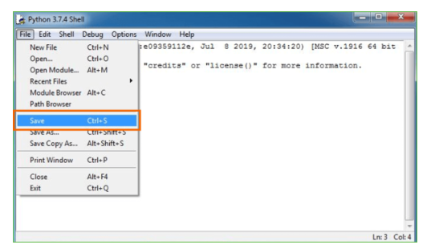
Step 5: Name the file and save as type should be Python files. Click on SAVE. Here I have named the files as Hey World.
Step 6: Now for e.g. enter print

SCREENSHOTS:
Video forgery will manipulate video with fake or forge content to deceive viewer and this forge video cannot be detected with human eyes so we are using Deep Neural Network (DNN) algorithm which will get trained on Forge and Real videos and then this trained model can be applied on any new test video to detect weather video frame is Real or Forge.
DNN algorithm get trained on features of Forge and Real videos so it can easily differentiate between real continuous frames and the frame with discontinue pattern. Often forge frame will have some kind of discontinuous pattern and such features will help DNN algorithm in detecting real or forge video.
To train DNN algorithm we have used dataset from KAGGLE which contains nearly 60 Real and Forge videos and can be download from below URL
https://www.kaggle.com/datasets/neetusingla5/video-forgery-dataset
When we train DNN models on large number of videos then system is going out of memory so we trained this model on 60 videos and then tested this model with some Forge and Real videos which downloaded from below GITHUB URL.
https://github.com/aaronchong888/DeepFake-Detect/blob/master/train_sample_videos/metadata.json
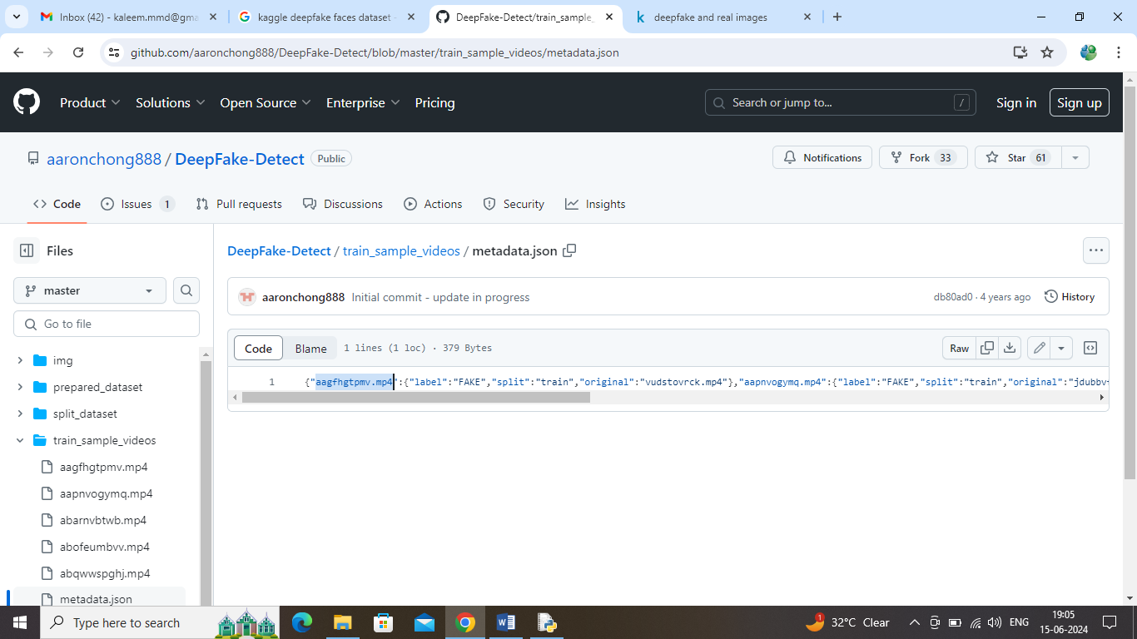
In above GITHUB URL screen you can see ‘aagfhgtpmv.mp4’ video is fake and ‘abarnvbtwb.mp4’ is the real video and this model is successfully predicting this videos as Forge and real. This link videos we used only for testing model
This project will take video as input and then generate new video by removing all forge frames and you can see generated real video in a file called ‘video_after_removing_forge.mp4’.
To implement this project we have designed following modules
- Upload Video Dataset: using this module will upload video dataset to application and then extract frames from each video and then create a training array with video features
- Shuffle & Normalize Video Frames: all extracted video features will be processed by shuffling and normalization
- Split Frames Train & Test: split frames features into train, validation and test part
- Train DNN Model: training and validation features will be input to DNN algorithm to train a model and this model will be applied on test features to calculate prediction accuracy
- Video Based Forgery Detection: input test video can be upload and then DNN will predict real and forge frame and then create a new video by ignoring forge frames.
SCREEN SHOTS
To run project double click on ‘run.bat’ file to get below page
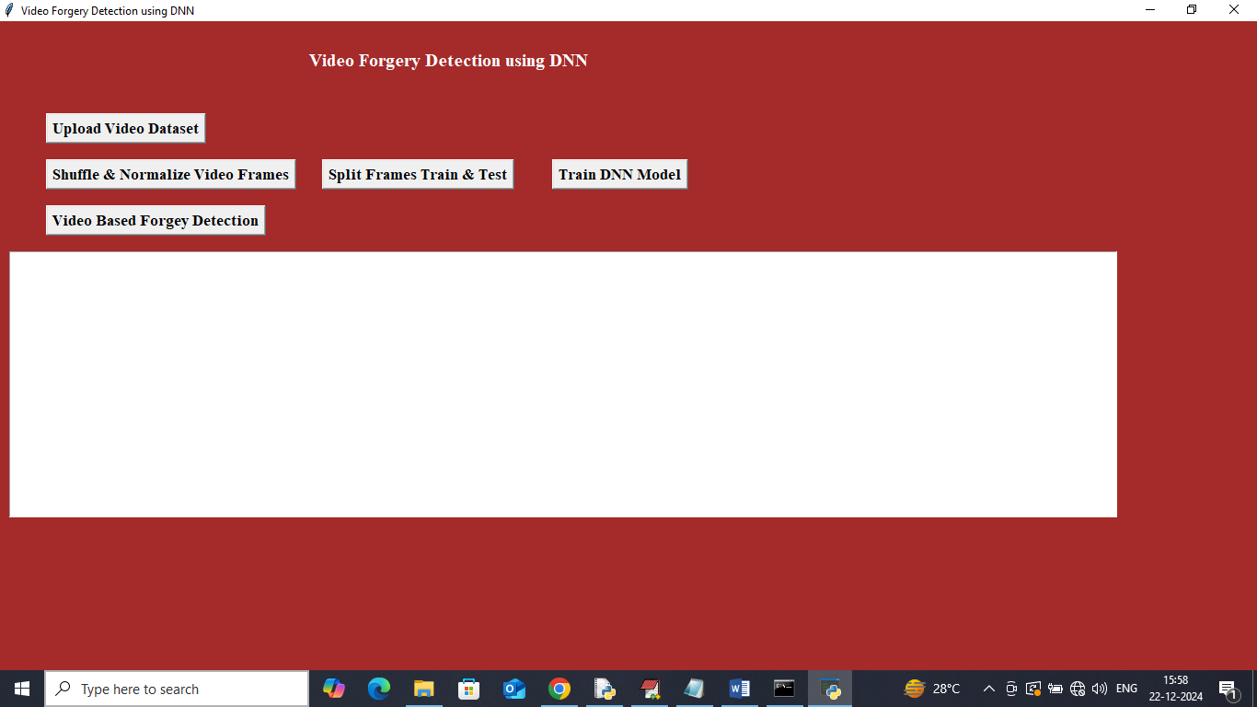
In above screen click on ‘Upload Video Dataset’ button to upload videos and get below page

In above screen selecting and uploading entire ‘Dataset video folder’ and then click on ‘Select Folder’ button to get below page
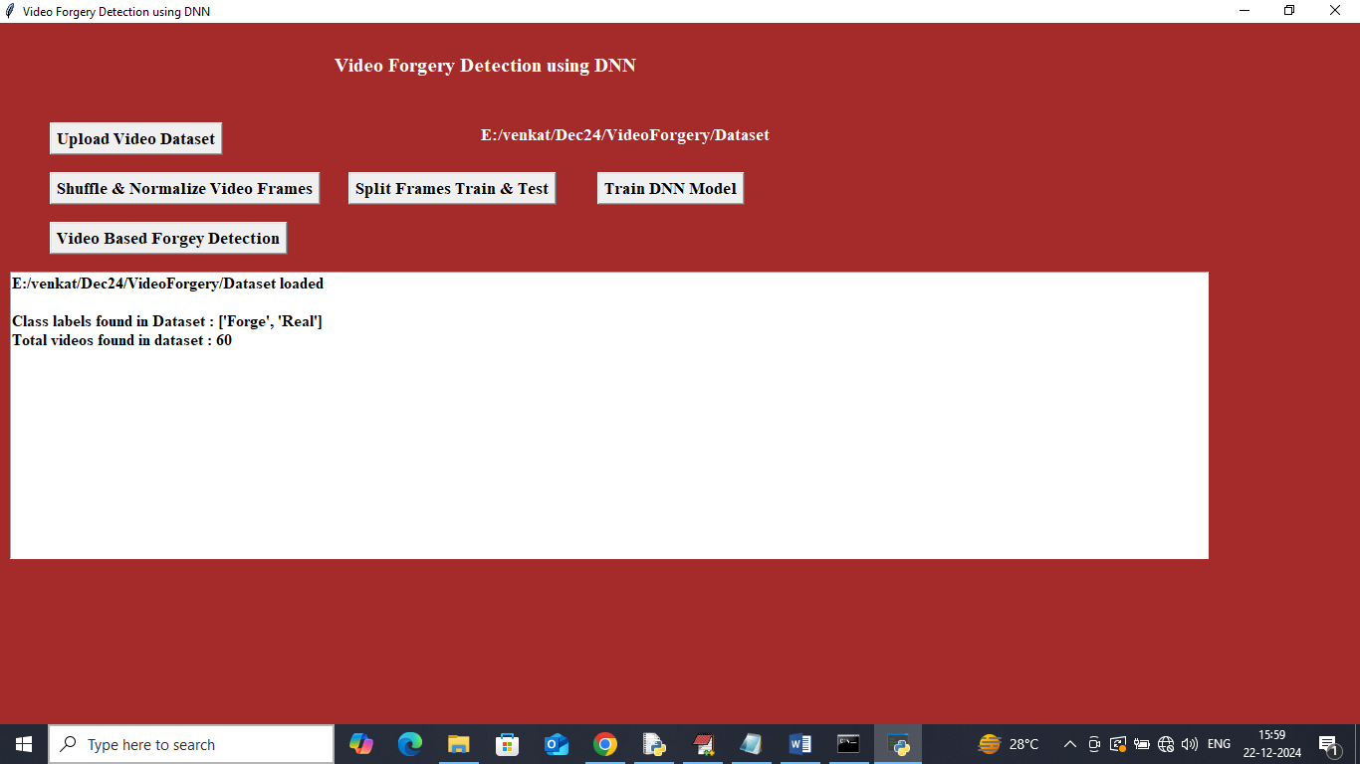
In above screen can see dataset contains 60 videos with Real and Forge classes and now click on ‘Shuffle & Normalize Video Frames’ button to process features and get below page
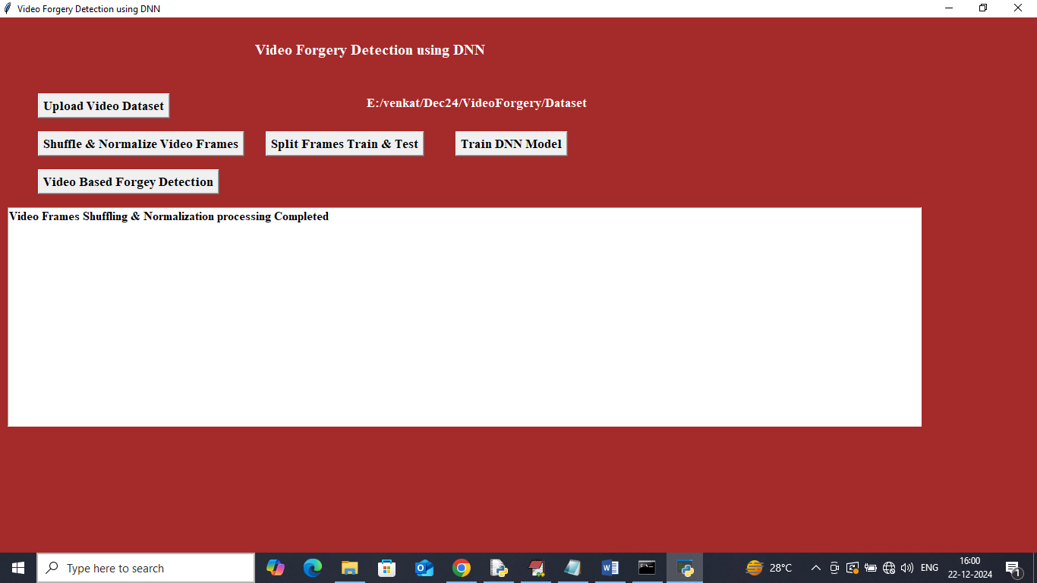
In above screen dataset shuffling and normalization processing completed and now click on ‘Split Frames Train & Test’ button to split features into train and test and then will get below output
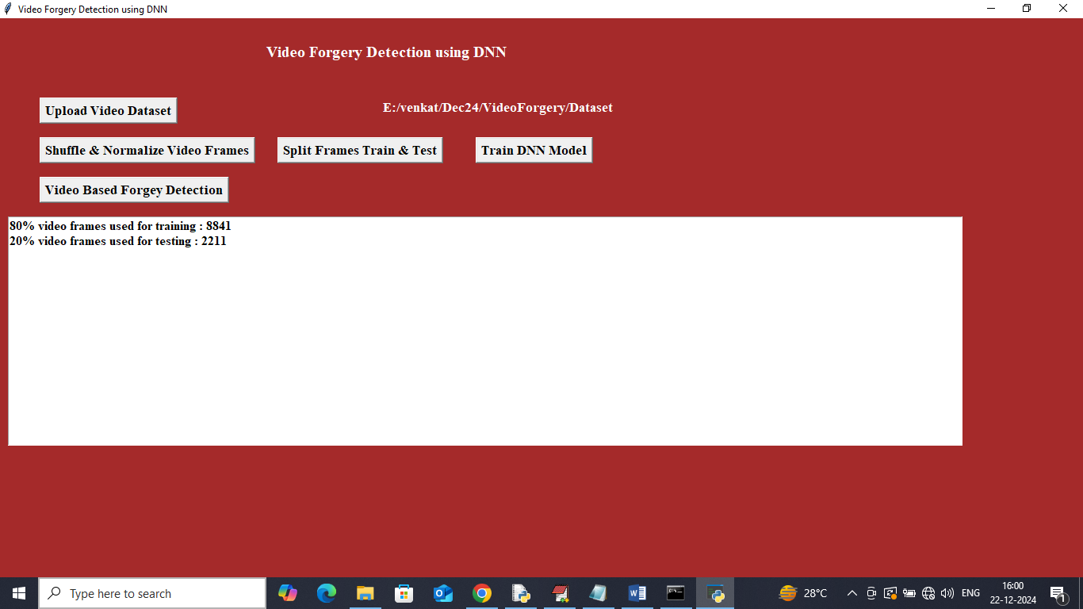
In above screen 8841 frames are using for training and 2211 frames are using for testing and now click on ‘Train DNN Model’ button to get below page
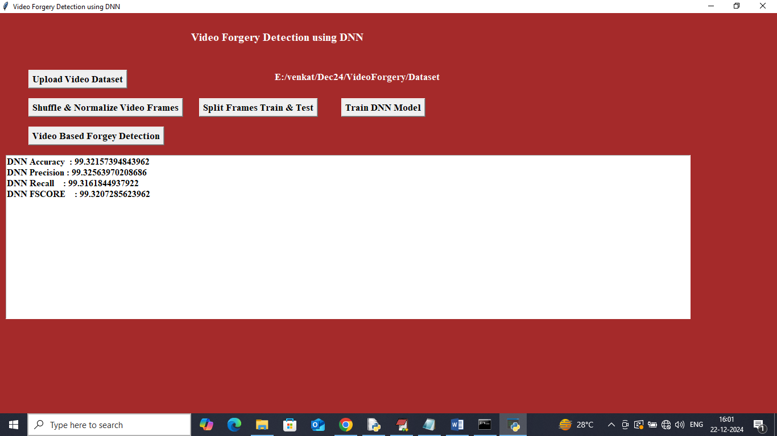
In above screen DNN model got 99% accuracy and can see other metrics like precision, recall and FSCORE. Now click on ‘Video Based Forgery Detection’ button to upload test video

In above screen selecting and uploading ‘test video’ and then click on ‘Open’ button to get below page
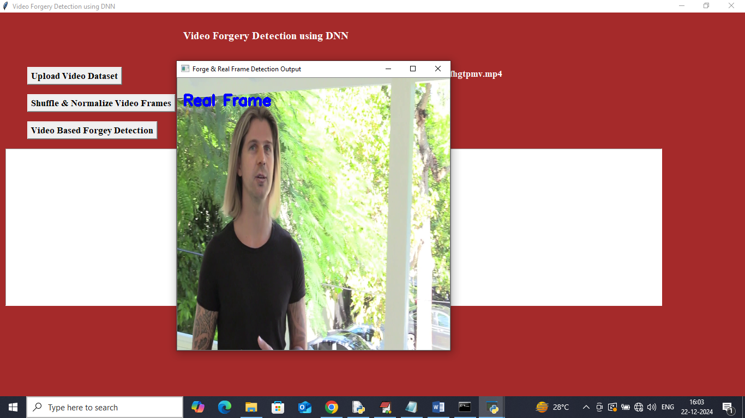
In above screen DNN detected frame as REAL
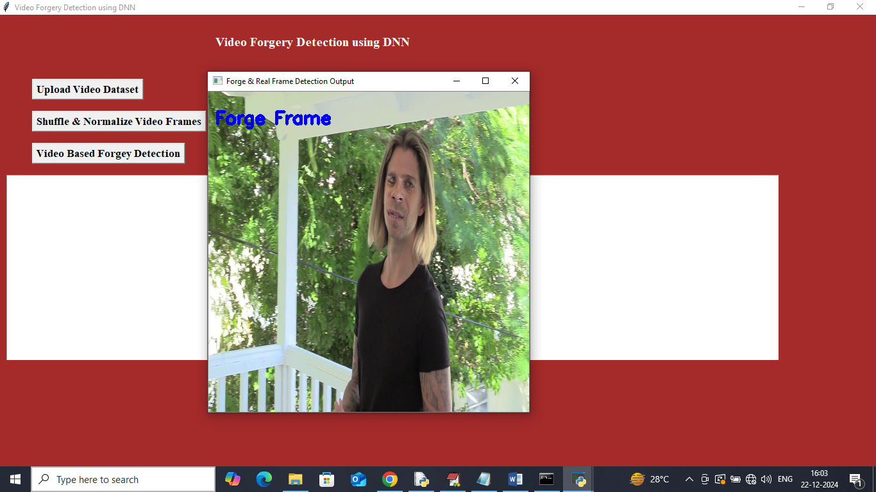
In above screen DNN detected frame as Forge. Similarly you can upload and test other videos
In below screen playing video after removing forge frames

In above screen frames which are playing in generated video containing only real frames
Conclusion:
Effectiveness of Deep Neural Networks
Deep Neural Networks (DNN) have proven to be highly effective in detecting video forgeries. Their ability to learn intricate patterns and features from data makes them well-suited for identifying anomalies introduced by forgery techniques such as deepfakes, frame insertion, and frame deletion.

Accuracy and Robustness
DNN-based methods have demonstrated superior accuracy and robustness compared to traditional approaches. They excel in detecting subtle manipulations that are often imperceptible to human eyes. By leveraging large datasets for training, these networks can generalize well across various types of video forgeries.

Challenges in Detection
Despite their success, challenges persist in video forgery detection. Adversarial attacks and increasingly sophisticated forgery techniques pose significant hurdles. Additionally, ensuring real-time detection while maintaining high accuracy remains a technical challenge for DNN models.

Future Directions
The future of video forgery detection lies in the development of more efficient and explainable DNN architectures. Combining DNNs with complementary techniques, such as blockchain for provenance tracking or multimodal analysis, could further enhance detection capabilities. Ongoing advancements in computational power and algorithm optimization will play a critical role in overcoming current limitations.

Conclusion
DNNs are a cornerstone of modern video forgery detection. While challenges remain, their potential for growth and improvement ensures they will continue to be a vital tool in safeguarding the authenticity of digital video content.
FUTURE WORK:
Enhanced Model Architectures
Future research can explore advanced DNN architectures, such as transformer models and generative adversarial networks (GANs), to improve the detection of subtle forgeries. These models can potentially capture spatial and temporal inconsistencies with higher precision and robustness.

Real-Time Detection Systems
Developing lightweight and efficient DNNs that can operate in real time is an important direction. This involves optimizing models for edge devices and ensuring low latency without compromising accuracy.

Cross-Domain Generalization
Forgery detection systems need to perform consistently across diverse video sources, formats, and resolutions. Future studies could focus on transfer learning and domain adaptation techniques to improve cross-domain robustness.

Explainability and Interpretability
Incorporating explainable AI techniques into forgery detection models can enhance their trustworthiness. Providing interpretable insights about why a video is flagged as forged will be critical for applications in legal and security domains.

Adversarial Robustness
Investigating the impact of adversarial attacks on DNN-based forgery detection systems and developing countermeasures to protect against these attacks is another promising area of research.

Integration with Blockchain Technology
Combining DNN-based detection systems with blockchain for video provenance tracking could help ensure the integrity of video data. Blockchain can provide a transparent and immutable record of a video’s creation and modification history.

Large-Scale Datasets and Benchmarking
The development of comprehensive datasets with diverse forgery types and real-world scenarios is essential for robust model training and evaluation. Future work could focus on creating standardized benchmarks for performance comparison.

Hybrid Approaches
Exploring hybrid methods that combine DNNs with traditional signal processing and statistical techniques could leverage the strengths of both approaches, leading to improved accuracy and reliability.

Ethical Considerations and Bias Mitigation
Addressing biases in training datasets and ensuring ethical deployment of forgery detection systems will be crucial. Future research could focus on fairness-aware learning and the ethical implications of automated forgery detection.

Collaborative Research and Open Platforms
Encouraging collaboration between academia, industry, and governments can accelerate innovation in video forgery detection. Building open-source platforms for testing and validating DNN-based systems will facilitate broader adoption and improvements.

REFERENCES:
Detecting Forged Facial Videos using Convolutional Neural Network
Authors: Neilesh Sambhu, Shaun Canavan
Abstract: This paper proposes using smaller convolutional neural networks (CNNs) for detecting forged facial videos, demonstrating improved performance over current state-of-the-art methods.

VideoFACT: Detecting Video Forgeries Using Attention, Scene Context, and Forensic Traces
Authors: Tai D. Nguyen, Shengbang Fang, Matthew C. Stamm
Abstract: The authors introduce VideoFACT, a network that detects and localizes various video forgeries by utilizing forensic embeddings, context embeddings, and a deep self-attention mechanism.

Autoencoder with Recurrent Neural Networks for Video Forgery Detection
Authors: Dario D'Avino, Davide Cozzolino, Giovanni Poggi, Luisa Verdoliva
Abstract: This study presents an approach combining autoencoders and recurrent neural networks to detect video forgeries by learning intrinsic models of source videos and identifying anomalies.

A Survey on Video Forgery Detection
Authors: Sowmya K.N., H.R. Chennamma
Abstract: This survey provides an overview of prior literature and challenges in video forgery detection, emphasizing passive approaches.

Deep Feature-Based Forgery Detection in Video Using Parallel Convolutional Neural Network: VFID-Net
Authors: Vinay Kumar, Manish Gaur, Vineet Kansal
Abstract: The paper proposes VFID-Net, a parallel CNN architecture for detecting interframe video forgeries by analyzing deep features and achieving high accuracy.

Video Forgery Detection and Localization with Deep Learning Using W-NET Architecture
Authors: Bhanu Tokas, Venkata Rohit Jakkinapalli, Neetu Singla
Abstract: This work introduces a W-NET architecture for detecting and localizing video forgeries, leveraging deep learning techniques to improve detection performance.

Real-Time Object-Based Video Forgery Detection Using YOLO (V2)
Authors: Punam Raskar, S.K. Shah
Abstract: The authors present a real-time approach for detecting object-based video forgeries, specifically copy-move attacks, using the YOLO V2 object detection model.

Watch Those Words: Video Falsification Detection Using Word-Conditioned Facial Motion
Authors: Shruti Agarwal, Liwen Hu, Evonne Ng, Trevor Darrell, Hao Li, Anna Rohrbach
Abstract: This paper proposes a multi-modal semantic forensic approach to detect video falsifications by analyzing word-conditioned facial motions, capturing person-specific biometric patterns.

Exposing Video Forgeries by Detecting Inconsistencies in Motion Residuals
Authors: Xuan Cao, Liming Jiang, Jiayi Ma, Zongben Xu
Abstract: The study introduces a method to expose video forgeries by detecting inconsistencies in motion residuals, utilizing deep learning techniques to enhance detection accuracy.

Deep Learning-Based Video Forgery Detection Using Recurrent Neural Networks
Authors: Mohammad H. Asghar, Sajjad Dadkhah, Saeed Shamsolmoali, Naoufel Werghi
Abstract: This research presents a deep learning-based approach employing recurrent neural networks to detect video forgeries, focusing on temporal inconsistencies for improved detection.

